

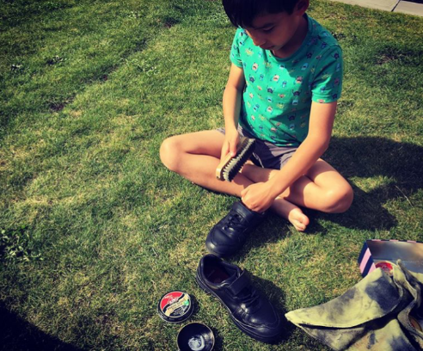
Observation – Conor – Polishing shoes

14.9.19 Home
After getting new shoes in September, Conor wanted to polish them. We discussed the importance of the leather needing polish to protect it. Conor identified the letters K-I-W-I on the tin, which he said was “too tricky” to open. Using a cloth he circled the polish into the leather shoe. “It smells strong!”, Conor exclaimed. He then used the brush and buffed each shoe. He was pleased with how shiny they were. “Shall we do your shoes now, Daddy?” was Conor’s response to this rewarding task at home.

