

Kirkby la Thorpe CE Primary Academy
Remote Learning Survey – January 2021
60 responses in total

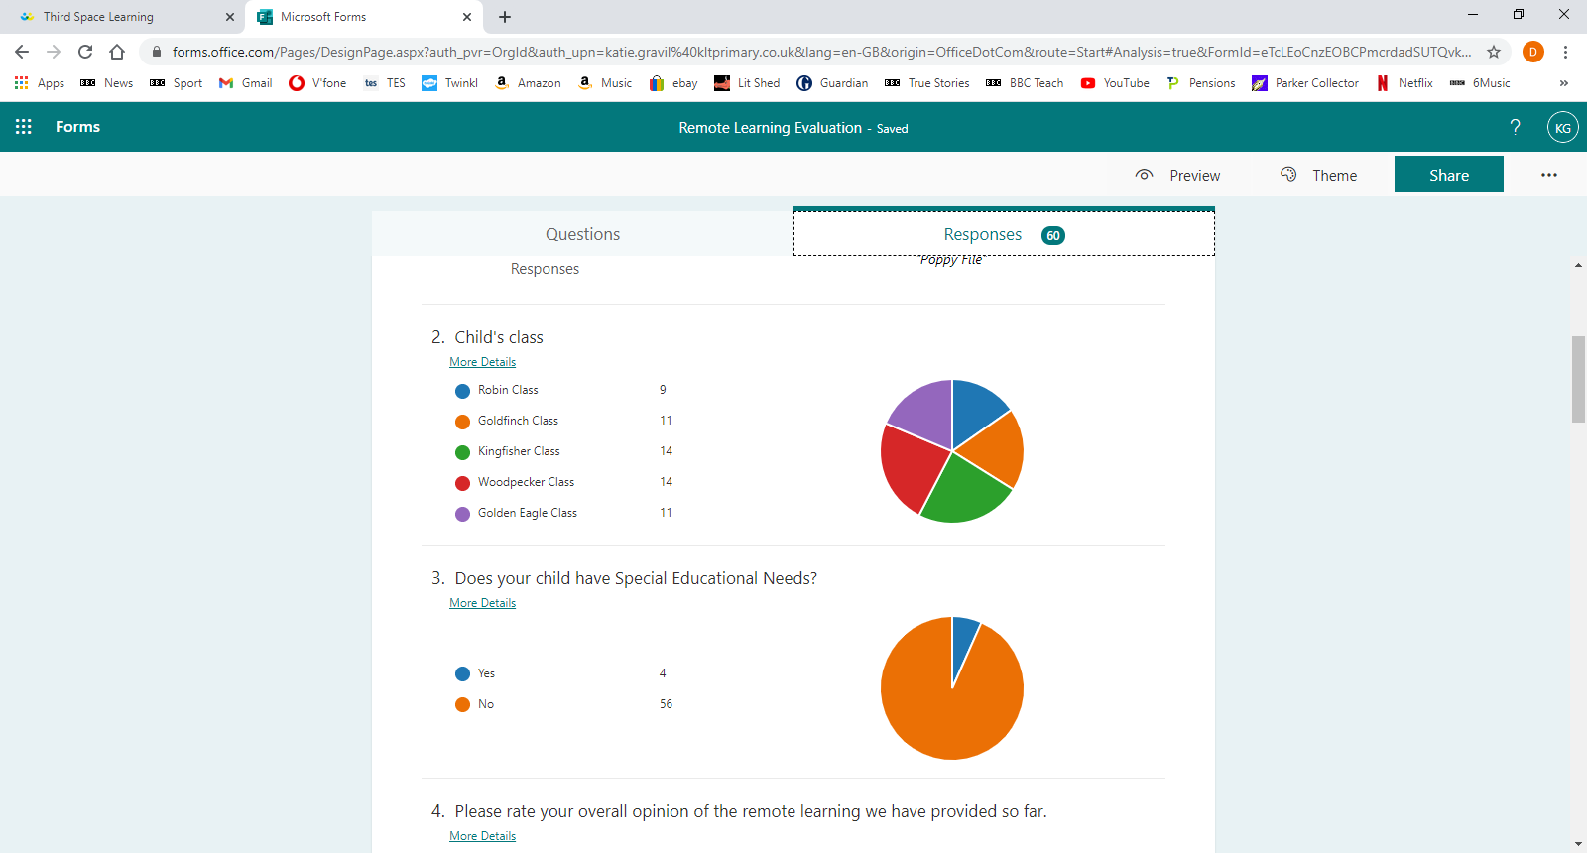
15%

18%

23%

23%

18%

7%

93%

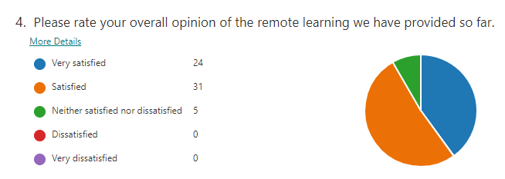
40%

52%

8%

0%

0%

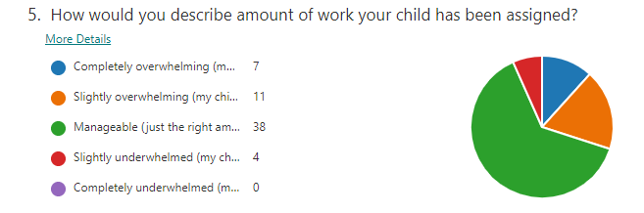

12%

18%

63%

7%

0%

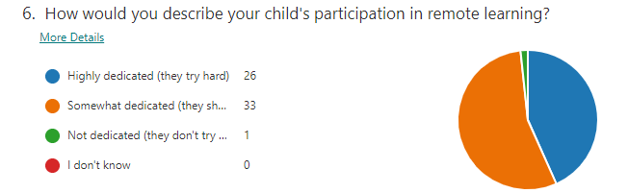
43%

55%

2%

0%

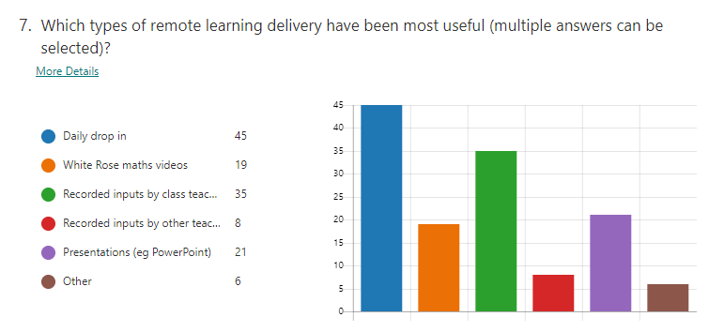
75%

32%

58%

13%

35%

10%

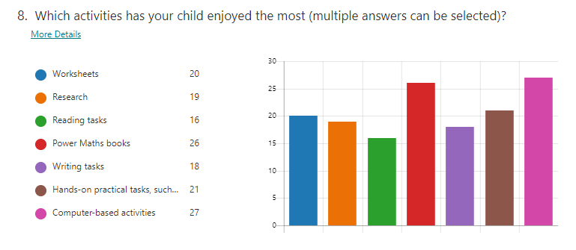
33%

32%

27%

43%

30%

35%

45%

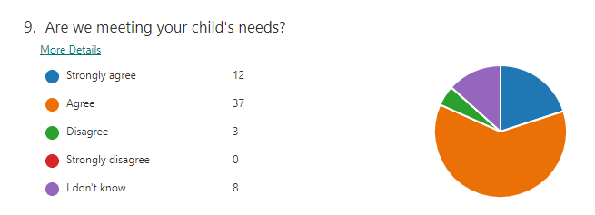
20%

62%

5%

0%

13%

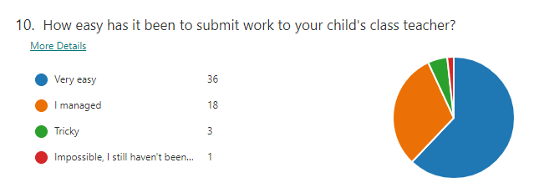
60%

30%

5%

2%

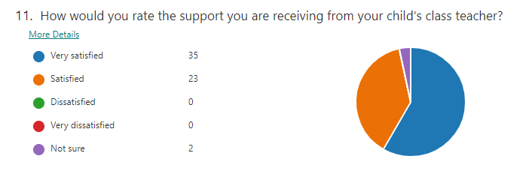
58%

38%

0%

0%

3%

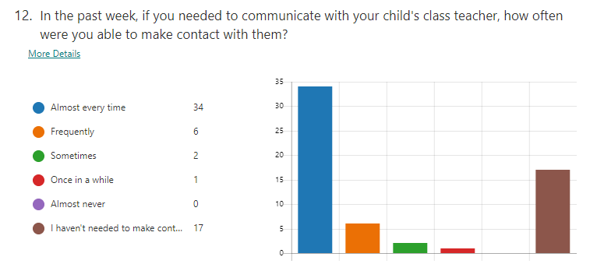
57%

10%

3%

2%

0%

28%

What parents/carers think is working well:
- Variety of work provided
- How work is organised and set out
- Where work is provided for the whole week, parents/carers like this flexibility
- Work is accessible at all times, which fits around working families and where there are a number of school aged children
- Daily teams meeting with class teachers
- Class teacher videos
- Powermaths books
- Being able to upload work for teachers to provide feedback
- Prompt and supportive feedback from staff; a parent acknowledged how this is often out of ‘work hours’
- 1:1 sessions being provided, included the Third Space Maths sessions
- The time and effort of teaching staff
- Individual comments, complimenting specific members of staff

Improvement suggestions by parents/carers
Below is a list of the suggestions that parents/carers made in relation to our remote learning provision. Where possible we have acknowledged and responded to each of these and value the input from our families.

- Changes to how work is provided/set out; some parents would prefer work to be uploaded by day rather than subject, to save moving between files.

Whilst we acknowledge this suggestion, a significant number of our families commented that they are happy with the current layout of work provided so this is a difficult one to remedy! Please contact your child’s class teacher if you are having particular difficulties accessing the work and they will endeavour to assist you.

- Work to be uploaded sooner, so that parents/carers have more time to read and prepare learning/activities.

Where possible, the latest staff upload work is the night before, for the following day. If they are able to, they upload work sooner than this, but as all staff are currently in school every day teaching the pupils in attendance, as well marking and responding to work, this is not always possible. This suggestion has been acknowledged by staff and we will assist where we can.

- More variety with the White Rose maths videos; some families find the pace of these too slow and that the monotone delivery, by someone unknown to their child, makes learning less accessible.

Again, this has been acknowledged by staff. Where they can find material that is of a higher quality than the White Rose maths videos, they will try to provide greater variety for the Maths’ inputs.

- Amount of work; some parents/carers think there is too much, some think there is not enough. Some parents/carers suggested ‘catch up’ slots to ensure that their child completes the required amount of work.

Due to the wide ranging needs of our family, this is always going to be a difficult area to please everyone. Where parents/carers feel there is too much work, please prioritise English and Maths activities over other tasks that have been provided; it is important that these subjects are maintained as much as possible.

From the week beginning 1st February, staff have built in ‘catch up’ slots so that pupils have time to go back to activities that they may not have been able to complete previously.

As some parents/carers would like more work, teachers are providing ‘optional extras’ should all planned activities be completed.

- Difficulty in gauging the standard of work their child is producing; some families would prefer greater guidance on whether the amount and standard of their child’s work is sufficient.

We recognise that parents/carers may find it difficult to gauge whether the amount and quality of work produced by their child is appropriate for their age group or ability. If this is an area you would like support with, please contact your child’s class teacher via email. They will then be able to give you guidance relating more specifically to the individual needs of your child.

- Reduced use of PDFs; parents/carers prefer formats that can be adapted on screen and do not need to be printed off and uploaded.

We recognise the difficulty with the use of PDFs and staff will try to limit the use of these, where possible.

- Less worksheets.

Again, this is acknowledged by staff and where worksheets can be reduced, we will try to do this.

- More live lessons.

Many of our families have commented that they like the ability to access the pre-recorded videos in terms of fitting this around their own work commitments. We acknowledge that this could also be achieved by recording live lessons, but the logistics of teaching a lesson to both a set of children at home, along with the children in the classroom, makes this a difficult task. Such sessions are more likely to take place over a longer period of time, extending pupils’ screen time, something we are trying to keep to a minimum. This would also be more difficult for families with multiple school aged children, where there is limited access to devices within the home. The use of the daily drop-in is evolving and teachers have been utilising this to address common misconceptions that pupils may have had with particular aspects of learning. We will continue to review the use of live lessons, but this is not something that we intend to introduce at the moment.

- Concern that their child ‘may slip through the net.’

This is something that we are very aware of and have already set up 1:1 and small group sessions with Teaching Assistants to meet the needs of specific children. If you have concerns about your child please make contact with your child’s class teacher so that these can be addressed.

- Access to reading books, rather than using Oxford Reading Tree.

Please see this week’s KLT update (Friday) which outlines how we intend to address this request.

