
Kirkby la Thorpe Church of England Primary School
Our School’s SEND Information Report
September 2026

At Kirkby la Thorpe, our key values of ‘kindness’, ‘learning’ and ‘tolerance’ underpin all that we do in our school. We strive to provide our children with an education that supports and develops them as rounded individuals. giving opportunities that enable them to achieve every day. We aim to ensure our children are secondary school ready and are prepared for life in what will be their modern Britain.

We want our children to be:
- positive and active citizens, with the ability to communicate clearly with others;
- tolerant and respectful of one another’s differences, beliefs and aspirations;
- having the confidence and perseverance to be the best that they can be;
What should I do if I think my child has special educational needs?

Talk to us. In the first instance you need to talk to your child’s class teacher. If you require further information, contact Mrs Brown, our SENCO, or Mrs Early, the Head teacher. At our school we pride ourselves in the positive relationships we have with our families and are always happy to discuss any worries or concerns that you may have. We currently support children and their families across a wide range of SEND and will tailor support to suit individual needs.
How will the school respond to my concern?

We will listen to your concerns, and together with you and your child, agree actions to be taken. A decision will be made to distinguish if your child may have Special Educational Needs, or if they are underachieving. If necessary, a follow-up meeting within a reasonable timescale will be arranged, to allow time for the school to look into your concern.
How will the school decide if my child needs extra support?

Any decision will be based upon a variety of evidence, ensuring that a child centred approach is taken. These may include:
- a full scrutiny of any assessment information
- observations of your child by the class teacher and other adults in the setting
- discussions with your child
- discussions with parents or carers
- reference to the guidance issued from the Education Authority on the criteria for SEND
• if relevant, the SENCO may ask other external agencies to observe or work with your child to gain additional expert advice.

- have the courage to respectfully challenge, their own, fully informed opinions, even if these differ from others and
- knowing their local and national heritage, having a sense of where they are from
Staff follow a clear procedure so they can identify any barriers to learning as early as possible.

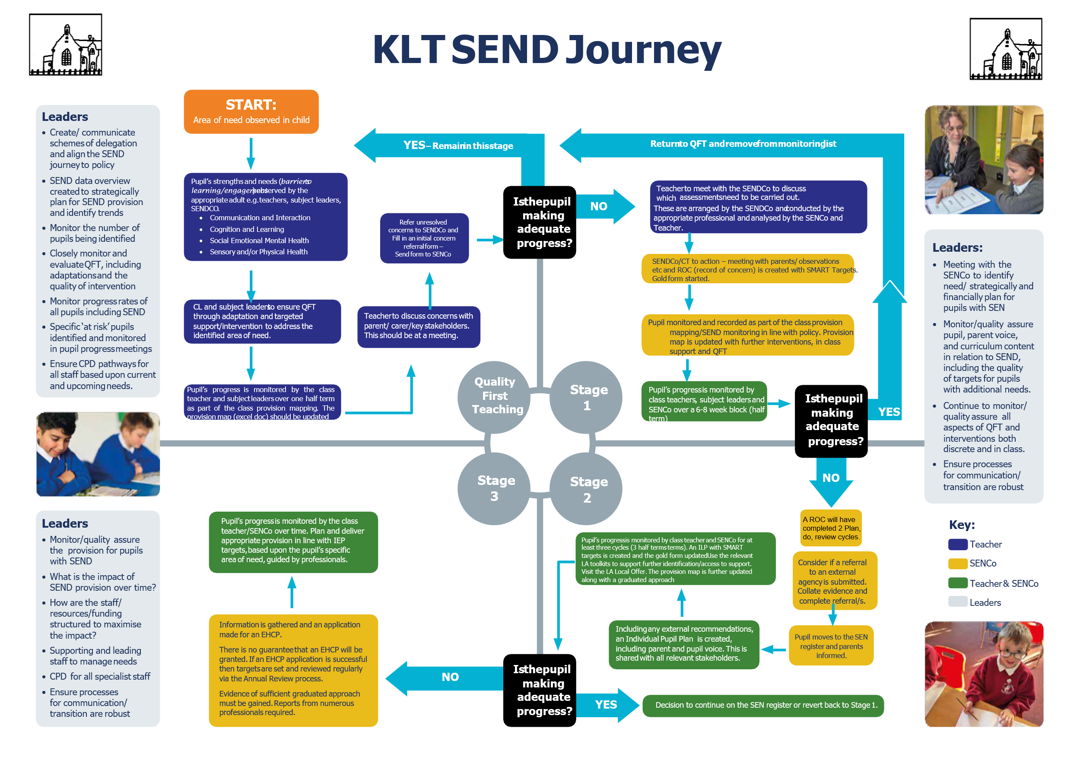
What will the school do to support my child?

If it is decided that your child requires additional support beyond that which they receive in class, (quality first teaching), a cycle of: assess, plan, do, review will be put in place. Targets will be set and their progress monitored by the class teacher, at a minimum of once a term. You and your child will be included in all discussions and decisions.

Support for your child may include:
- In class support – additional adults to support with following instructions, completing tasks etc. Additional provisions and learning support materials.
- Small group support – this may be inside or outside of the class, useful in developing working relationships.
- 1:1 support– may be in class or outside the classroom, may be used for more individualised targets, reading, spelling, etc.
• Outside agency support – may be in the form of an observation or intensive teaching usually done on 1:1 or 1:2 basis with a specialist.

All agreed actions will be placed on an Individual Learning Plan which is closely monitored by the SENCO, senior leadership team and the head teacher.

The process of providing support is:

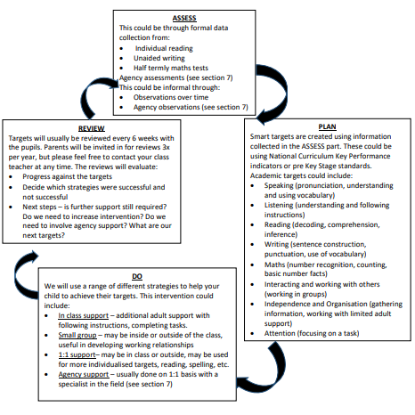

We may also put into place a range of structured intervention strategies, including:

Cognition and Learning | Communication and Interaction | Social, Emotional, Mental Health | Physical and Sensory Need
-Plus 1 or Power of 2 maths coaching –  -1:1 Reading (phonics, reading)  -RWI phonics intervention  -Precision teaching (phonics, spelling, maths)  -Language for Thinking  -Morph Mastery  -Widgit  -Pre and/or Post Learning Sessions  Morph Mastery | - Speech and Language programmes (as directed by Therapist)  - First Call activities - Wellcomm speech and language toolkit  -Socially Speaking Programme  -Widgit | -Casy Counselling  -Social stories  -Socially Speaking programme  - Support from ELSA  (Emotional Literacy Support Assistant) | -First Move (motor skills support) –  -Physiotherapy programmes (as directed by Therapist) - Sensory Circuits - Sensory programmes based on sensory profiling

Who will support my child?
Who? | How and Why?
Class Teacher | Sets targets based on your child’s needs. Will be ultimately responsibility for ensuring the intervention is provided and is effectively monitored.
SENCo – Mrs Rebecca Brown | Can support class teachers with effective target setting.  Monitors the effectiveness of intervention groups.  May complete referrals to other agencies for advice and support, including writing letters of your child’s need to GP’s/Paediatrician. Will lead specific review meetings and complete relevant paperwork.
Teaching Assistants (in class) | Day to day support within the classroom with in-class tasks (might be 1:1 or in small groups).
SEN Teaching Assistants | May provide support for reading, spelling, memory games, structured programmes (such as Plus 1 or Precision Teaching), basic maths skills either through 1:1 or small group work. Directed by the teacher to support the targets set.
Speech and Language support from a Teaching Assistant | Provides support for children with speech and language difficulties, following programmes set by the Speech and Language Therapist.
Midday Supervisors | May provide support for monitoring and supporting personal, social and emotional needs of your child through playground games, initiating play, monitoring progress in a specific area (e.g. forming friendship groups). Directed by the teacher to support the targets set.
Administration | May send out communication on behalf of the SENCo.
Additional agency support | May be asked for advice on pupils. May complete assessments or observations to support with further details regarding children’s needs.  Will support with target setting.  Will be involved in the review process and deciding next steps.
SEND Governor -Mrs Vicky Smith | Overseeing and evaluating the overall provision for SEN.

What training and experience do staff have for the additional support my child needs?

All teaching and non-teaching staff have been trained and are regularly up-dated on:
• Safeguarding
• PREVENT
• Paediatric First Aid
• Keeping Children Safe in Education
• Online Safety

All teachers and teaching assistants are highly experienced in teaching children with a wide range of abilities. Individuals and groups have training in the following areas
• Understanding and managing behaviour
• ELSA – Emotional Literacy
• Autism awareness
• Sensory profiling and sensory awareness
• PDA
• Language for Thinking
• Attachment
• Strategies to help learning for SEN pupils
• Team Teach
• Precision teaching
• Various structured intervention programmes
• Team Around the Child
• Early years specialists
• Paediatric first aid
• Anxiety in Autism
• Trauma awareness

The SENCO holds the National Qualification for the Co-ordination of Special Educational Needs.
Kirkby la Thorpe (KLT) has access to professional support from the Specialist Teaching Team (STT) who advise on teaching and learning with a focus on specific learning difficulties (SpLD) such as dyslexia and the Working Together Team (WTT) who advise and support teaching and learning of students with Autistic Spectrum Disorder (ASD).

Who else might be involved in supporting my child?

Sometimes it may be necessary to involve outside agencies in your child’s care. This will be planned in advance and you will be invited to talk to your child’s teacher or the SENCo about this beforehand. You will also be able to meet with your child’s teacher or SENCo to discuss the outcome of this. It is sometimes possible for parents/carers to meet with the agency, but this is taken on a case-by-case basis.

Outside agencies may include:

• Educational Psychologist (EP)
• Specialist Teaching Team, (STT)
• Working Together Team (WTT)
• Speech and Language Therapy, (SALT)
• Sensory Education Support Team - for children with visual or hearing needs (SEST)
• Behaviour Outreach Support Services (BOSS)
• Community Paediatrician
• Healthy Minds Team
• Dyslexia Outreach
• Early Help Team
• Physiotherapy
• Child and Adolescent Mental Health Service, (CAMHS)
• Occupational Therapists
• Early Help Worker

We can also make referrals or write letters to inform other agencies of issues regarding Education, Health and Safety. These include;
• GPs and paediatricians
• Children’s Services
• Child and Adolescence Mental Health Service (CAMHS)
• Portage
• Physiotherapy
• Speech and Language
• Healthy Minds

If a child needs the support of a different agency, then we would make our best endeavours to ensure that this happens.

What support will be there for my child’s emotional and social well-being?

Pastoral and Social Support
• We are an inclusive and welcoming school with a strong Christian ethos. All staff understand that the self-esteem and happiness of children is crucial to their well-being.
• We have a structured Personal, Social and Health Education (PSHE) programme. A range of techniques are used in lessons to promote speaking, listening, empathy and other social rules. Scenarios that the children may experience are also explored, and problem-solving strategies are developed.
• All children participate in creating their Class Charter which is referred to throughout the year.
• The playground rules are on display outside as a constant visual reminder.
• All lunch time supervisors receive training to support their interactions with children.
• Children in Year 5 are trained in peer mediation to help support children to resolve minor disagreements on the playground.
• Playtime Leaders in Year 5 receive training to support our younger pupils in their play.
• We have a clear behaviour policy which is adhered to by all staff.
• All child protection issues are reported to the school’s Designated Safeguarding Lead.
• We have a member of staff trained in child counselling.

Medical Needs
• If your child has a long-term medical need, a Health Care Plan will be put in place.
• The school has a policy regarding the administration and managing of medicines on the school site. If medicine is prescribed by a health professional that needs to be administered by the school, parents/carers are required to complete the appropriate form. This policy is available to view on the school’s website.

Supporting Behaviour, Avoiding Exclusion and Increasing Attendance
• All children are involved in writing Our Behaviour Code which is on display in all classrooms.
• The school has a positive approach to all behaviour with a clear reward system.
• If your child has specific difficulties regarding behaviour, they may have an individual plan or a Pastoral Support Plan.
• The Lincolnshire Ladder of Behaviour Intervention is followed, where necessary. Additional support through a Pastoral Support Plan may be initiated in certain circumstances.
The support provided will follow the ASSESS, PLAN, DO, REVIEW process as outlined on page 3.
• The attendance of all children is monitored daily, fortnightly and half termly. Each half term, certificates are awarded for ‘good’ attendance (97+%) or where attendance has improved by 5%.

Well-being
• Well-being and mental health are routinely discussed in each class and children are taught strategies which positively improve their mental health and well-being, as well as being given time to actively practice these strategies.
• Self-regulation and other exercises from the BOSS toolkit are used throughout the day as a way of regulating children’s emotions.
• Metacognition strategies are discussed in classes in order to improve children’s awareness of themselves and their learning styles.

How will my child be able to contribute their views? How will my child be involved in the process?
We value the views and opinions of all children at KLT, and there are many channels for them to express their thoughts and ideas on all aspects of school life.
• Children receiving small group and individual intervention, will have the opportunity to discuss their targets and progress at times of review; this will be recorded on an ‘All about me’ sheet.
• If your child has an EHCP, (Education and Health Care Plan), their views will be sought prior to the meeting and they will attend the meeting if deemed appropriate.
• In preparation for adulthood, children are asked to reflect on their ambitions (this could include higher education, employment, independent living, or participation in society).
• The School Council has representatives from Year 2, to Year 6. A ‘Suggestions Box’ allows all children in school to contribute any ideas they would like discussed at the council.
• Children can also express their views and suggest activities on environmental issues through the Eco Committee.
• An annual questionnaire is conducted where we actively seek the views and opinions of the children. The results are fed back, with a description of any actions that will be taken.
• Subject leaders talk to groups of children, including children with SEND, about what they like about a subject and how it could be improved.
How will the curriculum be matched to my child’s needs?

All children, including those with SEND, benefit from the strategies employed in quality teaching to make adaptations for learning, so that all children can achieve. Some children require support that is ‘additional to and different from’ the rest of the class. Some of the strategies used are as follows:

• Groupings - Children may be placed in similar or mixed ability groups; pairs or larger groups, depending on the task.
• Visual Aids – for example visual timetables, displays, working walls, word maps.
• Concrete Apparatus – such as hundred squares, base 10 apparatus.
• Computing – Children with SEND may make an audio recording of their work, or represent it as an image.
• Adaptive Teaching– the learning outcomes are the same but adaptations will be made so that all children can fulfil their potential.
• Scaffolded Work – some children may benefit from work which has been partially completed, so the child focuses on the key points only.
• Class teachers are encouraged to use dyslexia friendly strategies wherever possible in their classrooms.
• use of pre-learning and post-learning to share key points of the learning prior to the lesson so your child is more prepared.
What opportunities will there be for me to discuss my child’s achievements? How will I know how well my child is progressing?
•We have an open-door policy. You may make an appointment to discuss your child’s achievements at any time during the year.
• In addition to the three parents’ evenings during the year, children with SEND will have their targets assessed and reviewed on a termly basis (x3/year). This takes place at a meeting to which both you and your child are invited.
• Learning drop-in, hosted by SENCo, held termly.
• If your child has an EHC Plan, an annual meeting will take place to which all agencies involved will be invited, as well as yourselves. This is in addition to the termly reviews.
• Occasionally, it may be decided to set up a manageable home-school book or chart to communicate your child’s progress, or to monitor any aspect of your child’s learning that has been agreed upon with you and your child.
• If external agencies are supporting your child, they may make appointments to discuss their progress.

If your child is on the SEN register, you will be invited to a review meeting three times during the academic year (once a full term). This review meeting will be with the Class Teacher and SENCO (where appropriate). In these meetings progress against your child’s targets will be discussed and new targets will be set.

Children on the SEN register are also involved with writing and reviewing their own targets, which includes celebrating their achievements. If you wish to discuss your child’s progress at another time, appointments can be made with the teacher or SENCo.

How does the school know how well my child is doing?

We carefully track all of our children’s progress from entry to Year 6, across each term through the use of data and observations. Data is recorded on the school’s tracking system.

This includes:
• Assessment against the National Curriculum programmes of study
• PIVATs (Performance Indicators Value Added Target Setting) – to measure small steps before the National Curriculum for children in Year 1 and above.
• Early Learning Goals and milestones – for children working within EYFS
• Early Years’ Small Steps document for EYFS children to measure small steps progress.
• Teacher assessments
• Pixl Tests
• End of key stage assessment papers
• Reading and spelling ages
• Assessment for learning – within the classroom, self and peer assessment, use of talking partners to share ideas
• Progress against Individual targets
• Any assessments provided by outside agencies involved
• All children are screened for dyslexia at Y2

These help to identify areas to target and support to move your child forward.

How will my child be included in activities outside of the classroom including school trips?

All children are included in all areas of the curriculum and in all aspects of school life. In discussion with you and your child, we will provide the necessary support to ensure that this is successful.

Risk assessments are carried out prior to any off-site activity to ensure that all health and safety needs are met and to ensure accessibility for all children.

Our breakfast club, Larks, and after school club, Owls, are managed and run by two members of staff with the Head teacher overseeing.

How accessible is the school environment?

Apart from the staff room and SENDCo office, all areas of the school can be accessed by a wheelchair.
• There is a toilet with disabled access, which is large enough to accommodate changing clothes with adult support if necessary.
•We carry out an accessibility survey annually to ensure that this is consistent and no additional areas of development are identified, and this is carried out more regularly should the need arise.
•We use ICT equipment such as iPads and laptops to support children’s learning and use specific equipment and resources to support individual and specific needs.

How will the school prepare and support my child to join the school?

• The school has an Open Day each October so that any prospective parents/carers can come and view the school in its daily routines.
• Additional visits or discussions are accommodated.
• The Reception class teacher visits all preschool settings to start developing relationships with those children starting at our school.
• All parents/carers of children starting at our school are invited to an information evening in the summer term.
• Reception children are offered an opportunity to spend three half days with their class teacher to help familiarise themselves with the layout and routines of the school.
• If your child has already been identified as having SEND, the school’s SENCO will also visit the preschool setting so that the child has as smooth a transition as possible.
• If your child is joining us further up the school, we can offer taster days to your child and additional meetings with you, as necessary.
• The school has a system of assessments to complete within the first fortnight of your child starting our school so that their progress can be accurately monitored from the start.

How will the school prepare and support my child to transfer to a new setting?

Moving to Secondary School
• Throughout Years 5 and 6 there are many opportunities for our children to visit the local secondary schools; whether this is for sporting events or for more formal taster days. Both provide valuable occasions for your child to become familiar with their next school.
• All of the secondary schools in Sleaford have a member of staff responsible for preparing Year 6 in their transition. Part of their role is to visit the children in their primary setting to allay any fears that they may have, and to give the children an opportunity to ask as many questions as they like. • If a child is particularly anxious about moving to secondary school, then additional visits are arranged.
• If applicable, early annual review meetings are held to which the SENCO from the relevant secondary school are invited, ensuring that all objectives related to a child’s EHCP are still current and relevant.
• All paperwork relating to SEND are forwarded to respective secondary schools.
• Arrangements for a meeting between SENCOs is put in place, if it is felt necessary.

Moving to the Next Class
As we are a small school, the teachers and the children know each other well, making transition a less formidable process. There are several whole school events throughout the year, such as Eco Day and Christmas Card making day, where the children may be taught by other members of staff.

Transition between year groups also involves:
• Sharing of information between class teachers (including paperwork, successful strategies)
• ‘Moving up day’ where your child will meet their new teacher.
• Children with specific needs may need a personalised social story book with photos showing the changes they will face in preparation for the following year.
• You can meet with the class teachers and SENCo to discuss transition plans and any additional support that might be needed for your child.

Transferring to a different school, other than secondary
• We liaise closely with staff when receiving and transferring children to and from different schools, ensuring all relevant paperwork is passed on, and all needs discussed.

How will school prepare and support my child to transfer to secondary school?

We understand the transfer to secondary school can be a daunting time for everyone and maybe even more so if your child has SEN. We will support you and your child by:
• Arranging visits for a range of days and activities throughout Year 6.
• Inviting the SENCo from the secondary school to attend the last review meeting of year 6.
• Organising agency support for transition, e.g. Working Together Team.
• Providing information about the needs of your child to their transferring school through paperwork, emails, meetings or phone conversation.
• Completing transition booklets to support your child in becoming familiar with the new routines of the school, e.g. maps, timetables, photos of key members of staff.
• Organising additional visits to the school as necessary.

How can I be involved in supporting my child?

The most important thing you can do for your child is to give them your time! If you chose only one thing…read to them! Share a book each day and focus on reading for pleasure.

We often give parents/carers:
• Games for developing memory, spellings, maths
• Useful websites and apps
• Strategies for reading, e.g. reading to your child, with your child, before they read to you
• Specific agency advice – could be games, organisational strategies (e.g. visual timetables), behaviour management strategies
• Letters to support referrals to Paediatricians
• Help your child with organisation - ensure that all items they bring to school, including their PE kit, are ready, organised and clearly labelled.
• Be interested in the topics they do in school.
• Encourage them to bring in relevant artefacts that could be shared with the class.
• Encourage independence wherever possible.

Parents/carers are always encouraged to support within school through:
• Donating spare time, e.g. to listen to readers, check spellings
• Share your own talents, e.g. art, sports, career advice
• Share your knowledge of your child, e.g. through review meetings, parent consultations
• Joining us to celebrate success, e.g. talent days, music events, craft afternoons, art exhibitions.

How can I access support for myself and my family?

The best way to access details for any type of support and help is through the Lincolnshire Local Offer website www.lincolnshire.gov.uk/send-local-offer .

Other useful contact details may include:

Organisation | Contact number | Website/email details
Kirkby la Thorpe CE Primary Academy | 01529 302595 | www.kltprimary.co.uk  enquiries@kltprimary.co.uk
Lincolnshire County Council Support and Aspiration | 01522 782030
Lincolnshire Children’s Services | 01522 554673
Children’s social care/Lincolnshire’s Safeguarding children’s board | 01522 782111 (if you are concerned about a child)
Emotional Well-Being and Mental Health |  | http://search3.openobjects.com/kb5/lincs/fsd/family.page?familychannel=2_9_9
Safeguarding concerns linked to Female Genital Mutilation | 0800 0283550 - helpline | fmghelp@nspcc.org.uk
Domestic Abuse – ‘together we can stop it in Lincolnshire | North Kesteven/South Kesteven  01427 616219  01522 510041 | www.lincolnshire.gov.uk  then enter ’domestic abuse’
Early Help and Team Around the Family (TAF) |  | www.lincolnshire.gov.uk  then search for Early Help or TAF
Lincolnshire Parent Carer forum | 07925 232466 | https://www.lincspcf.org.uk/  admin@lincspcf.org.uk
Parent Partnership | 01522 553351 | www.lincolnshireparentpartnership.org.uk
Lincolnshire ADHD Support Group | 01522 539939 | Lincoln.adhd@btconnect.com
The National Autistic Society  Lincolnshire Autistic Society | 0845 070 4002  01775 821213 | https://www.autism.org.uk/directory/l/lincolnshire-autisticsociety
Lincolnshire Centre for Grief and Loss | 01522 546168 | email@lcgl.org.uk
Family Information services |  | email: fis@lincolnshire.gov.uk
4All | 01522 555517 | http://www.lincolnshire.gov.uk/parents/disability-and-sensory-impairment/4all/
Contact a Family  Support on any aspect of raising a child with a disability | 0808 808 3555 | www.cafamily.org.uk
Gingerbread  Single parent helpline | 0808 802 0925 | www.gingerbread.org.uk
National Society for the Prevention of Cruelty to Children | 0808 800 5000 | help@nspcc.org.uk
Home-Start – support for parents | 0800 068 6368 | www.home-start.org.uk

Who can I contact for further information?

• Your first point of contact will always be the class teacher. You may also arrange to meet the SENCO, Mrs Brown, or the Head teacher, Mrs Early.
• Emails requesting further information can be sent to: enquiries@kltprimary.co.uk
• The school telephone number is 01529 302595

